1. Visual Concepts Photography will be photographing our students in our dance studio Tuesday May 6th , Wednesday May 7th and Thursday May 8th.

Picture Day Info

1. *General Info*:
   1. Students come to their assigned time (approx.. 5-10 min early) dressed and ready in their recital costume
   2. You may choose to do their hair and make up how they will wear in the recital, or however you like.
   3. Students enter the large studio with staff. Parents can sit in lobby or one of the other classrooms (we do not have parents come into the room as it is highly distracting- if we need you- we will come get you!)
   4. Picture times are about 20 min for a group. Please be prepared to run a bit over if needed.
   5. Once your child is finished, they will be dismissed.
   6. You will receive proofs of your child’s photo shoot before purchasing files.
2. Please view the excel sheet in the recital packet for exact times for your child’s class.
3. Students are not required to participate in pictures, but they are nice to have as a keepsake or use in the year end recital program.
4. Each student interested in taking pictures will need to pay a $20 sitting fee.
   1. The sitting fee is ONE per child (not per costume- meaning students with multiple costumes can take pictures in more than one costume with their sitting fee)
   2. The sitting fee will go towards purchase of files. Should you decide to pass on purchasing photos, the sitting fee will be forfeited.
5. Company members who are interested in a Headshot ONLY will need to pay a $5 sitting fee (which would go toward the purchase of file or be forfeited). Company members who are taking costume pictures, headshots would be included with the $20 sitting fee.
6. Sibling photos can also be taken.
   1. Siblings will go in a time slot with one of the child’s classes.
      1. Example: Sibling 1 is in the Saturday 10am ballet class, Sibling 2 is in the Tuesday 5:15 Combo class- Both siblings would come to the picture time for the 10am ballet OR the 5:15pm combo picture time for the sibling picture. Individual pictures would be during the classes normal picture time.
   2. Please let director or owner know if you’d like a sibling shot and they will tell you which time slot has more availability.
7. You will need to pick 2 backdrop options for your dancer. We aim to photograph each dancer on at least 2 backdrops. Please see backdrop choices below.
8. To book your child’s photos, you will need to use the google form (located in your email or on our website). You will need to fill out separate forms for each dancer AND for each costume (if they are in multiple numbers).
9. Once submitted, you will need to send your sitting fee ($20/child for costume pictures, $5/child for headshot ONLY):
   1. Cash (At Studio)- envelope labeled with your child’s name
   2. Check (At Studio)- made out to “Visual Concepts Photography”
   3. Venmo (camera emoji + child’s full name)- @Debbie-Ruymen (she is the photographer)
10. You will get proofs of your photos to look at before purchasing.  Please see website flyer for pricing information.  
      
    If you have any questions you can email us.  If we cannot answer we will connect you to Visual Concepts Photography directly.

**BACKDROP A**

*Gold Curtain*

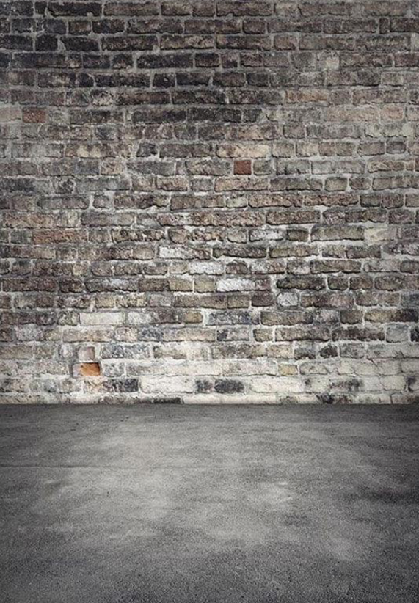

**BACKDROP C**

*General*

**BACKDROP B**

*Brick Wall*