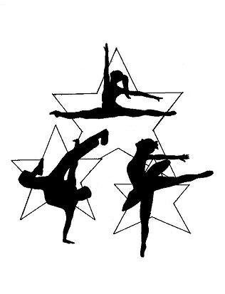

2025 Awards/Scholarship Info

- Recognition and Scholarship Awards- These awards are as follows:
    - I Love Dance- Presented to the student(s) who show absolute passion and love for the sport.
    - Dedication Award- While attendance does play some part, this is geared more towards the student(s) who’s dedication and commitment to their learning and their overall hard-work shines through in the classroom.
    - Rising Star Award- Trophy Presented to a Company Create member who shows true promise in the art of dance.
    - Ruth Hoelzle Memorial Scholarship- Presented to a Company Create member who displays excellence in all aspects and a strong desire to be the best dancer they can. They will receive a scholarship for the class of his/her choice for the 2025/2026 season ($500 value)
These students will be presented with their award at the recital.

- Trophies- For students who have studied 3 years, 5 years, 7 years, 10 years and 15 years AT Create Dance Center (please see list of students who are eligible on our website) Trophies will be picked up at the studio the week of dress rehearsal. Students will be announced on stage the day of the recital.
- Student Teacher Medals- For students who assist classes ALL YEAR as a student teacher.
- 2025 Graduates- The studio will acknowledge any student graduating from High School in 2025 at the final show of the weekend. Please make sure to check the list on our website!

Here’s to another fabulous recital after another amazing year!

